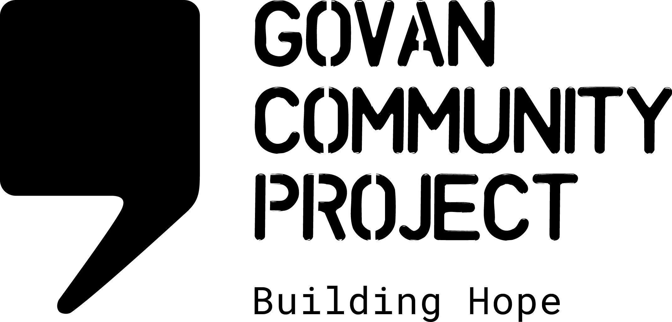
JOB DESCRIPTION

Job Title: | Comms Officer
Location: | initially office based in Govan, Glasgow  potential of blended working following probationary review
Hours Per Week: | 17.5 hours per week
Salary Scale: | £12,537 per annum (Full time equivalent £25,073)
Reporting To: | Head of Charity

OVERALL PURPOSE OF THE ROLE

The main purpose of the role is to support the development and delivery of creative and impactful communications content on various media platforms ensuring a consistent, co-ordinated approach to communications, marketing and branding.

The Comms Officer role will also involve supporting the wider team to ensure all public messaging reflects the organisations branding and values when promoting our activities & opportunities, commenting on policy & campaigning developments relevant to the asylum/refugee community and sharing information from partner agencies.

MAIN DUTIES AND RESPONSIBILITIES

Managing Social Media Comms

- Planning, creating and scheduling regular engaging content which promotes the work of GCP
- Increase engagement and following on GCP social platforms
- Support the involvement of GCP community members in developing content for social media
- Responding to direct requests/contacts made via social media and forwarding enquiries to the appropriate staff member
- Support the community fundraising team with digital campaigns
- Coordinate the roll out of any GCP marketing campaigns
- Manage the content on GCP’s website
- Work with partners to support collaborative social media campaigns
- Utilise digital resources, digital analytics and training opportunities to maximise traffic to social media and website

Comms & Marketing

- Regularly create impactful and engaging content for the website
- Create regular newsletters and grow the newsletter mailing list
- Produce ad hoc mailers for events and fundraising campaigns
- Establish media relationships and be the main point of contact for media enquiries, comments and press releases
- Work alongside the Head of Charity to draft statements in relation to relevant external news/policy changes
- Develop and maintain a marketing and communications strategy for the organisation
- Ensure branding guidance is up to date, communicated to the team and maintained
- Support the staff team with developing content which promotes projects and activities and maintains branding consistency
- Support the staff team with the creation of additional, ad hoc marketing materials e.g. posters, flyers, leaflets, annual reports
- Work alongside any web development support to enhance the website functionality (if available)

Networking & Collaboration

- Represent GCP and work collaboratively with colleagues through asylum/refugee specific comms channels
- Work with the Head of Charity and partner organisations on collaborative statements/campaign messaging
- Represent the organisation in other relevant comms networks and discussions
- Work with partnership agencies to support joint communications where appropriate

Reporting, Monitoring and Evaluation

- Produce regular data on traffic and engagement with media channels for internal use
- Provide quarterly and ad-hoc reports to Head of Charity
- Undertake research/consultation with community members on accessibility of social media
- Support the creation of the annual impact report and strategy documents

Other Duties

- Working as part of the staff team to maintain the values and ethos of Govan Community Project
- Adhere to all organisational policies and procedures
- Work with the staff team to contribute towards providing a safe, welcoming, clean and tidy environment for staff and visitors
- Attend meetings and contribute to strategic development
- Attend training as required and share learning with the wider team
- Perform any other tasks or duties deemed necessary

Occasional evening or weekend working may be required

PERSONAL SPECIFICATION:

Essential

- A minimum of 1 year’s experience working in a marketing, communications or public relations role
- Ability to create clear, engaging and audience specific content for different platforms
- A good eye for design, branding consistency and accessible communication
- Experience of managing content on social media platforms
- An ability to review, select and report on current affairs in relation to asylum and immigration
- A level of competency in using design platforms such as WordPress, Canva or Adobe and Mailchimp
- Experience in website content management
- A commitment to the aims of the organisation
- A flexible working approach and excellent organisation skills
- Ability to work autonomously in achieving work objectives
- Ability to work collaboratively with colleagues and partners

Desirable
- Experience/skills in developing video/audio content
- Lived experience of forced migration
- Ability to develop provide written content in a relevant second language e.g. Farsi, Arabic, Kurdish Sorani
- Experience working in the 3rd sector
- Knowledge of human rights, equalities and social justice issues

