17th December 2025

Dear Applicant

Position of Comms Officer

Thank you for your interest in the above vacancy with Govan Community Project. Enclosed with this letter is a copy of the job description, and a copy of our application form. The application form can be completed electronically, however we are also happy to receive paper applications.

The closing date for applications is Sunday 11th January 2026.. No late applications can be considered. Please note we require a completed application form and CV’s will not be accepted.

Should you require any accessibility support to make your application, please contact us.

We aim to hold interviews in the week commencing 19th January 2026.

To enable us to monitor diversity within our recruitment processes, we would be grateful if you could complete our anonymous diversity survey which can be accessed here: http://bit.ly/GCPHReqmonitoring, however this is not mandatory and opting out of this will have no impact on your application.

Completed applications being submitted by email should be sent to recruitment@govancommunityproject.org.uk. Paper applications should be sent to:

FAO Recruitment,Govan Community Project
31 Garmouth Street, Govan G51 3PR

We look forward to receiving your application.

Kind Regards
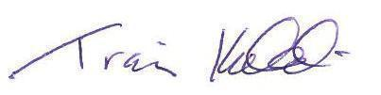
Traci Kirkland
Head of Charity

