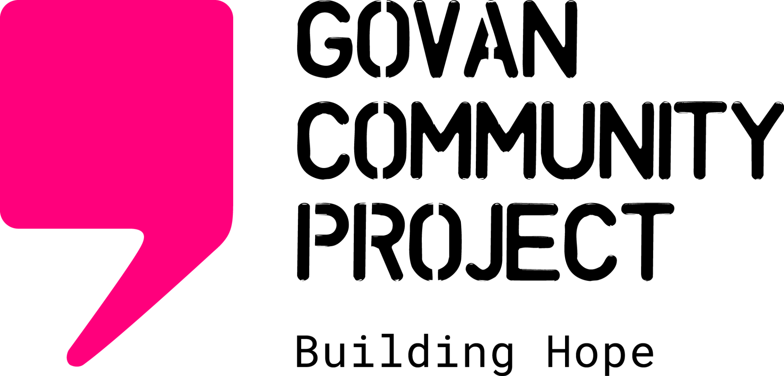
- This form is for external agencies to refer to the Advice & Advocacy Project only
- Please submit completed forms to adviceteam@govancommunityproject.org.uk
- Please note that our team does not work on Fridays

ADVICE & ADVOCACY REFERRAL

Name of referrer:
Referrer organisation:
Phone: Email:
Referral details  Name:  Date of birth:  Postcode:  Phone:  Interpreter required ☐  Language required: | Immigration status  ☐ Haven’t claimed asylum – but intend to  ☐ Asylum seeker  ☐ Further submissions/fresh claim  ☐ Asylum claim refused (ARE) or withdrawn  ☐ Refugee status/humanitarian protection  ☐ Leave to remain – with NRPF condition  ☐ Other:
What type of issue is the person experiencing?
☐ Eligibility or access to Home Office support (Section 95/Section 4/Section 98/Schedule 10)
☐ Home Office support stopped or about to be stopped
☐ Homeless or about to be made homeless
☐ Lack of appropriate housing/issue in current Home Office accommodation
☐ Access to food
☐ Access to healthcare (GP/dentist/midwife/mental health etc)
☐ Access to support for families (if claimed asylum within last 6 months please refer to SRC
families team first)
☐ Access to legal advice
☐ Social isolation
☐ Access to English classes
Support required Please expand on the type of support required

Current housing  Which option best describes the person’s current housing situation? Only answer if referring for housing/financial support.  ☐ Street homeless  ☐ Sofa surfing  ☐ Being hosted by friends or family  ☐ In Home Office accommodation  ☐ In Social Work accommodation  ☐ Private rental/Housing Association  ☐ Homeless accommodation  ☐ Other: | Financial situation  Which option best describes the person’s current financial situation? Only answer if referring for housing/financial support.  ☐ Home Office support (i.e. ASPEN card)  ☐ No regular income  ☐ Benefits (i.e. Universal Credit)  ☐ Working/savings  ☐ Social Work support  ☐ NRM support  ☐ NRPF support  ☐ Other:
Vulnerabilities Are there any vulnerabilities that you think we should be aware of?

Other agencies Have you made referrals to any other agencies/are any other agencies
already involved?

Please confirm the following with the person you are referring:
☐ I am aware that this referral is being made to Govan Community Project and have given
my consent
☐ I am aware of the reasons for the referral and the information being provided
☐ I agree for Govan Community Project to store this information and for someone from
Govan Community Project to contact me

Print name Date

